**CPA Payroll Week  
Functional Specification**

CONTENT

CONTENT 2

1 Overview 4

1.1 Campaign Calendar, Points 4

1.2 Features & Timelines 4

1.3 Multilanguage 4

1.4 Summary 5

1.5 Email Requirements 6

2 Screen BY Screen Specification 7

2.1 Sitemap 7

2.2 [NEXT VERSION: Landing page] 7

2.3 Template ‘Main’ 9

2.4 Page ‘Home’ 17

2.5 Page ‘Log In’ 21

2.6 Page ‘Enroll’ 23

2.7 Page ‘Profile’ 30

2.7.1 Profile Completeness 31

2.8 Events 31

2.8.1 Page ‘Events’ 31

2.9 Challenges 33

2.9.1 Page ‘Challenges’ 35

2.9.1.1 Page ‘Post a Response’ 38

2.9.1.2 Page ‘Response Details’ 40

2.10 Page ‘Downloads’ 43

2.10.1 Page ‘Download Details’ 45

2.11 Page ‘Forum’ 47

2.12 Page ‘Leaderboard’ 49

2.13 Winners 51

2.13.1 Page ‘Winners’ 51

2.14 Page ‘About’ 52

2.15 Page ‘Terms and Conditions’ 54

2.16 Page ‘Privacy Policy’ 54

2.17 Page ‘Community Rules’ 54

2.18 Page ‘Refer A colleague’ 54

2.19 Page ‘Tell us Your Story’ 56

3 Administrative Interface 59

3.1 Page ‘CPA Settings’ 59

3.2 Page ‘Challenges’ 62

3.2.1 Page ‘Add/Modify Challenge’ 62

3.3 Page ‘Challenge Responses’ 62

3.3.1 Page ‘Modify Response’ 62

3.4 Page ‘Winners’ 63

3.5 Page ‘Downloads’ 63

3.6 Page ‘Events’ 64

4 Appendix 65

4.1 User Permissions 65

4.2 Points 65

4.3 Badges 67

4.4 Sending Emails 69

# Overview

## Campaign Calendar, Points

It includes dates, events.

* Updated by Angelina and client:

<https://docs.google.com/spreadsheets/d/1pM0ATuyEIPjqX3iNkEPj-uCNuJVZc6DJ_acfO8fcxBw/edit#gid=2029780702>

Points and badges:

* Updated by Sam: <https://docs.google.com/spreadsheets/d/1SSceAFHqu76owdUnfrjhdFLoebtp7Xrr-LVpAAMpK-w/edit#gid=1034063564>

## Features & Timelines

High Priority:

* Setup email delivery system [Jul 2, 2020: I decided to use SendGrid for now. Waiting Dennis’s confirmation]

Low Priority.

* Can be Live after Aug 15:
  + Social Media Aggregation
* Can be Live after Aug 30
  + Tell Us a Story
  + Refer a Friend
* Can be launched after Sept 15 [Jun 30, 2020 confirmed by Sam]:
  + List of winners
* Social login [Jul 11, 2020 Sam confirmed – if it does not work for both languages then it can be hidden from the website at all];

DO NOT:

* No Blogs/Articles on the website

**TIMELINES**

* Teaser site: Live Aug 4 – Aug 14  (pre-registration, calendar of events)
  + Can be skipped and HOME page can be LIVE on Aug 4
    - HOME page may not include Challenges till Aug 15, can be ‘Coming soon’
* Go Live: Aug 15 (full site functionality)
* Payroll Week: Sept 21 -25
* Wrap Weeks: Sept 26 - October 15

## Multilanguage

Main domain: [www.poweredbypayroll.ca](http://www.poweredbypayroll.ca)

EN and FR website content URL depends on ML plugin.

Automatically redirect [www.propulséparlapaie.ca](http://www.propulséparlapaie.ca) on FR version of [www.poweredbypayroll.ca/fr](http://www.poweredbypayroll.ca/fr) [Jul 2, 2020: I opened a case to admin and Dima to configure such redirects]

[Tech Note:

Translation for Ultimatemember - <https://translate.wordpress.org/locale/fr-ca/default/wp-plugins/ultimate-member/>

Switch language based on user preferences - <https://wpml.org/forums/topic/switch-language-based-on-user-preference-choosed-in-registration/>

How to translate plugin, real-time notifications and emails - <https://docs.ultimatemember.com/article/1449-how-to-translate-plugin>

]

## Summary

**Summary:** CPA produces the National Payroll Week celebration every year, which is intended to promote the value payroll professionals deliver to the businesses they operate in. The one-week celebration typically involves a customized landing page (built/hosted by CPA) and a series of local events across the country hosted by regional volunteers. It also includes opportunities for payroll professionals to connect on social media, download posters and templates to host local events in their offices to promote the payroll function.

Due to the COVID 19 pandemic, CPA will not be hosting local events this year. Rather, they are running the campaign entirely online with a full week of digital events (webinars, seminars, panel discussions, social media promotions), including a few weeks of pre-launch promotions and an influencer marketing campaign to help drive traffic.

In addition, this year’s promotion will focus on engaging payroll professionals (and their support teams) to register on the campaign microsite for the possibility to engage in online tools (forum, blog post responses, social sharing, weekly or daily “Missions”-- all will result in collecting points on a leaderboard for the possibility to win weekly and/or grand prize.

CPA has partnered with “Dress for Success,” a not for profit organization that helps men and women seeking employment access professional clothing for interviews as part of a corporate social responsibility program.

This year’s campaign will be themed/titled “Powered by Payroll”.

*See attached PDF: PWN 2020 - Strategy Tactics for more background & details. .

**RESPONSIBILITIES:**

In general, CPA will develop, manage, and provide all content/events for this campaign. Sensei will only be responsible for the development/hosting of the website functionality, including email functionality for duration of the campaign.

**Sensei Requirements:**

* Design and develop a temporary community (English & French) campaign microsite- ideally utilizing existing templates/functions
* Responsive CMS-managed website
* English/French switch for all pages [SF> Read below, client will provide all copy. ]
* Pages aggregating social media feeds [SF> third party feed embedded into a page, such as one available through keyhole.co>
* Registration functionality [SF> Registration will likely use social media log in to become a member of the site. Then, we’ll have option for the user to update their profile (possible) with more information about them (maybe 3 or 4 text fields, tbd)]
* Content Marketing pages (blogs, articles, videos, infographics, downloadable documents (posters, etc., all provided by client))
* Links to event registration (existing third party registration site) [SF> This just a link. We will provide a listing of events by date with a link: “Register Now”  that will open a new window with the 3rd party site. It’s just a link. No functionality. ]
* NOTE: Digital events will be sponsored by CPA-partners. They will be promoted on the site and emails but registration will occur on 3rd party website and events will be hosted using the sponsor’s technology (Zoom, WebEx, etc.)
* Forum
* Leaderboard (similar to EMB leaderboard, earning points for various activities by members (E.g. registration, logging in, completing the survey, participating in the forum, social shares, video watch, etc.) [SF > No, we will post winners ~~in a blog post~~ in “winners” section (no blog posts on this site). It will not be automatic functionality. ]
* NOTE: final point winner will be called “Payroll Powerhouse” for being the best promoter during the campaign, will win a large prize provided by the client
* HTML and broadcast of planned emails to registered members promoting events and promotions, encouraging return visits. (all emails will be pre-planned/designed before the launch of the site) [SF> It’s up to us, I suggest we use MailCast like we do for ECHO or Morgan Stanley.]
* TBD: Use the platform to engage advocates, request for testimonials per marketing/business plan
* Site hosting/monitoring and analytics

**Client Requirements:**

* Branding guidelines, “Powered by Payroll” logo
* All content for the site (optional: upload content to site if necessary)
* French translations
* All event design and production
* All influencer outreach/management
* Media / Advertising
* PR

## Email Requirements

Email requirements:

* Desktop max width: 600px
* Mobile max width: 480px (optional, if Desktop and Mobile layout are the same)
* Text over image – text should be part of the image
* For each email:
  + FROM NAME
  + Subject Line (SL)
  + Preview text (SSL)
* Preferable creative in Zeplin (or PDF)
  + If email has a simple structure, then it can be in MS Word or PowerPoint

# Screen BY Screen Specification

[Jul 2, 2020: I decided to have two instances TEST and LIVE. LIVE will be configured for LIVE domain and email system]

Page title: [Jul 8, 2020 – site name confirmed by Angelina]

* Format: ‘*Powered by Payroll - <page name>*’
  + Example:
    - *Powered by Payroll – Home*
    - *Powered by Payroll – Downloads*
    - *Powered by Payroll – Events*
    - *…*

Website official hashtag [Jul 8, 2020 confirmed by client]: **#PoweredbyPayroll**

Website favicon [Open Issue: provide website icon: <https://app.asana.com/0/1181397601364668/1184139780815441>]

[Open Issue: what should be in place of most items/pages after campaign completes. Events? Downloads? Challenges? And so on <https://app.asana.com/0/1181397601364668/1184156465417089>]

## Sitemap

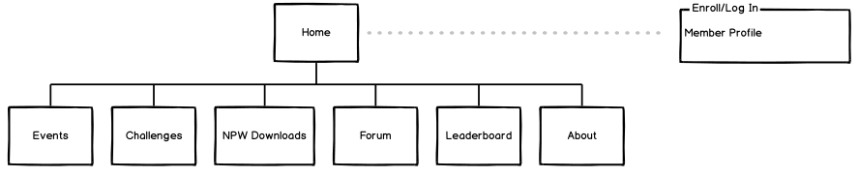

## [NEXT VERSION: Landing page]

[Jul 3, 2020: confirmed with Sam do not use Landing page if we can LIVE with Home page]

The goal of the landing page is to make pre-registration.

This page will be LIVE from Aug 4 till Aug 15. This page will be replaced by Home page after Aug 15.

It may look like this (for illustration only):

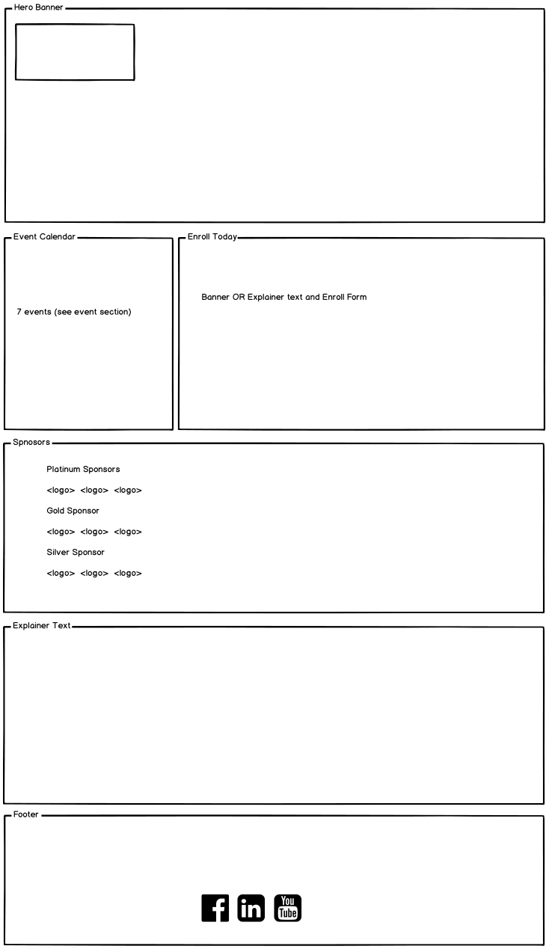

Controls description:

* NOTE: this page does not have HEADER, because this is pre-launch single page only.
* Section ‘Enroll Today’:
  + Incorporate Enrollment section inside the page. NOTE: if this is difficult then open Enroll as a separate page;
  + Expected workflow:

|  |
| --- |
| If user is **Logged In**, then   * This section shows a copy for logged in user. So user should not enroll again [Open Issue: please provide what should be in this block   [SF: This will be a new graphic that should appear in this position. It will be provided by the client.]]  If user is NOT Logged In, then this section should display a section Enroll section (the same as on the page ‘Enroll’)   * Once user enrolls (confirm his enrollment successfully), then:   + User should be automatically logged in;   + Save in cookies that user is automatically logs in next time when he/she opens the page. This is required because in 1 week this page will be replaced on Home page;   + This section should be replaced on the section as for Logged in user [Tech Note: if need – reload the page]. |

## Template ‘Main’

This template will be applied for almost all pages.

[Tech Note: Change ‘Register’ on ‘Enroll Today’ on the page]

This page may look like this (for illustration only):

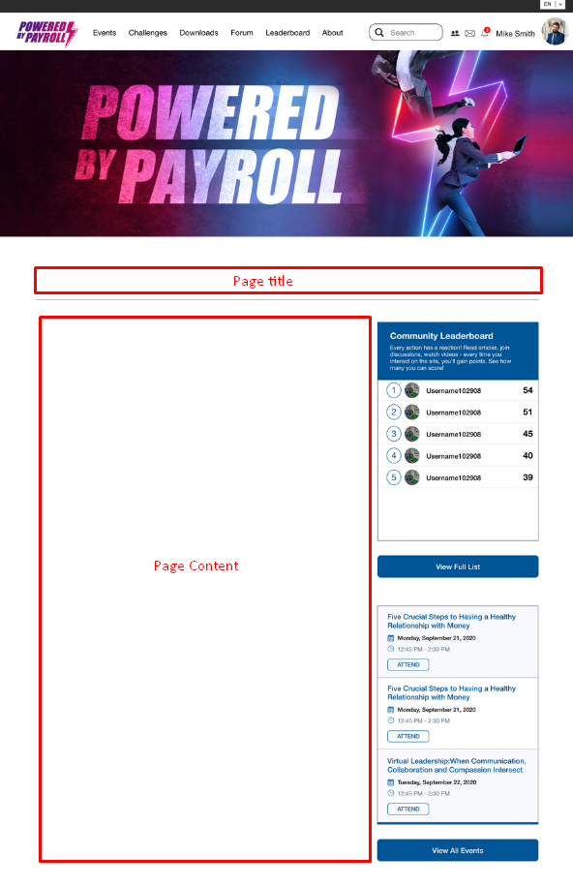

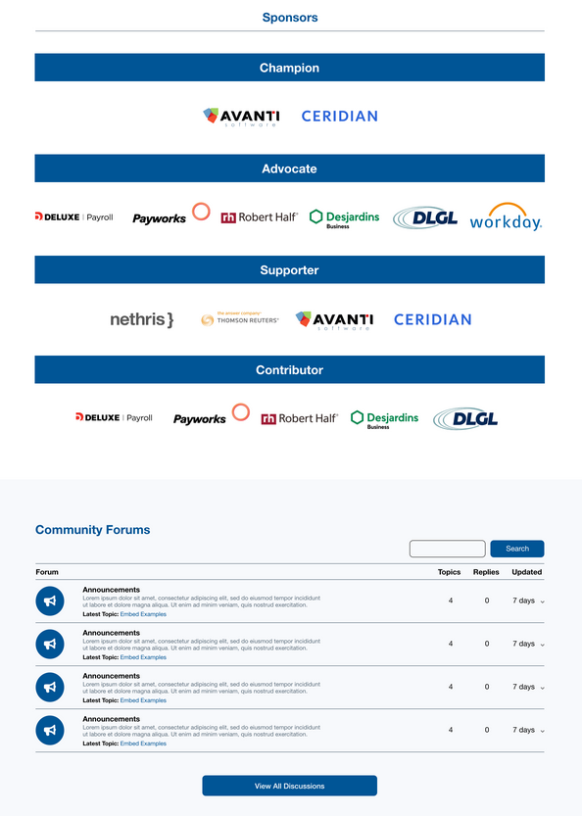

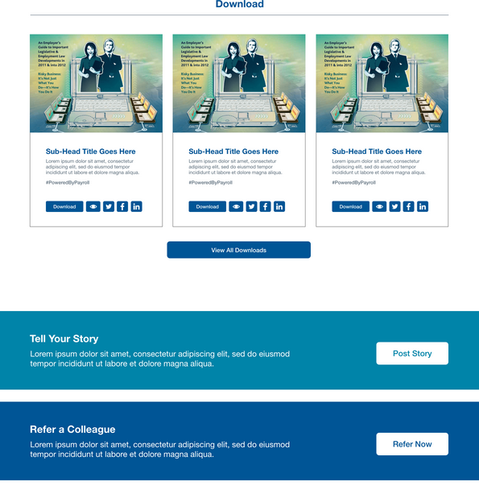

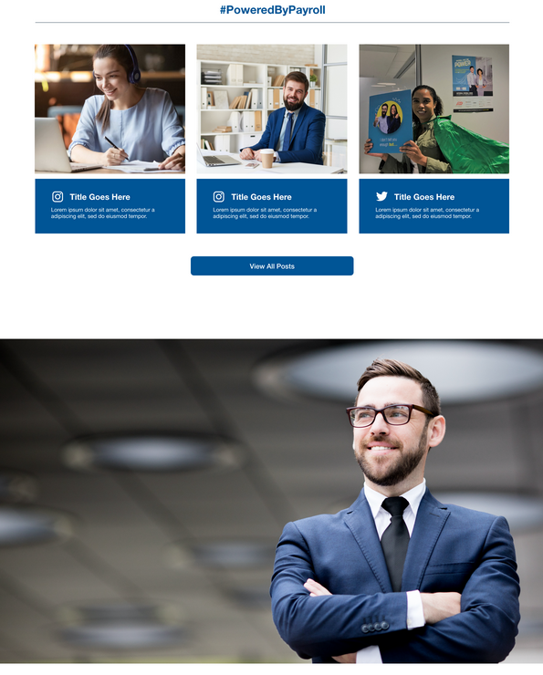

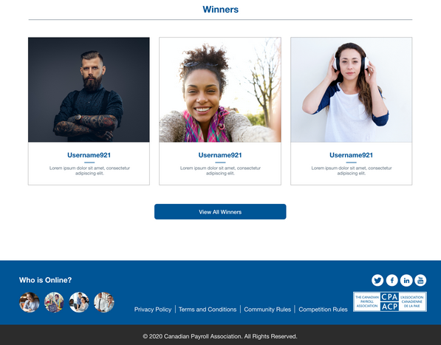

Controls description:

* Top menu:
  + Not logged in user:
    - Login. Opens Log in page;
    - Enroll Today! Open Enroll page;
  + Logged in user. Show something like this (for illustration only):



* + - NOTE: *Only notification icon should be here, all other features ‘Friend Requests’ and ‘Messages’ should be deactivated*
    - Notification area.
      * Use standard message for user activity, except earning points and gaining badges
        + Messages for points described in the chapter ‘Points’;
        + Message for badges described in the chapter ‘Badges’;
      * It may look like this:

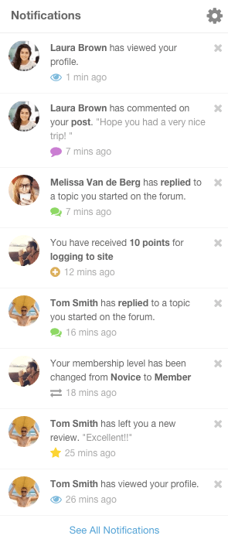;

* Language switcher:
  + EN / FR
* Sidebar:
  + Section ‘Event Calendar’
    - Display next 1-3 events. [Tech Note: display 3 events where [Event Date/Time] > [Current Date/Time]. Note: Convert server time to EST first];
      * Once events pass, then at the end of campaign will be 2,1 and 0 events;
      * If there are no events (all events passed) then do not display this section;
    - Clicking button opens ‘Events’ page in the same window;
    - See each *event tile field details* and *(not) logged in user actions* on the page ‘Events’;
  + Section ‘Leaderboard’
    - Display users with *Subscriber* role only;
    - Display top 5 users:
      * Place from 1 to 5;
      * User avatar;
      * User first and last name;
      * Points;
    - Clicking ‘*View Full List*’ opens page ‘Leaderboard’ in the same window;
* Section ‘Sponsors’, ‘Corporate’. Simple HTML sections
  + [Open Issue to Angelina: waiting links / logos for sponsors. With Angelina: <https://app.asana.com/0/1181397601364668/1183792093369213>];
* Section ‘Forum Discussion’
  + Show just a list of forums without search, add and navigation controls
  + Clicking ‘View All Discussions’ opens ‘Forum’ page in the same window;
* Section ‘Download’
  + These items are taken from **CPA Settings->Downloads** and displayed the same orders as inside that settings. See each download tile description on the page ‘Downloads’;
  + Clicking ‘View All Downloads’ opens page ‘Downloads’ in the same window.
* Section ‘Tell Your Story’. Clicking button opens the following:
  + If user is NOT **Logged In**, then open Log In page in the same window *AND with the same language as the current page*;
  + If user is **Logged In**, then open page ‘Tell Your Story’ in the same window.
* Section ‘Refer a Colleague’. Clicking button opens the following:
  + If user is NOT **Logged In**, then open Log In page in the same window *AND with the same language as the current page*;
  + If user is **Logged In**, then open page ‘Refer a Colleague’ in the same window.
* Section ‘Social Feed’ [Open Issue: from what social networks need to get data: Instagram, Facebook, Twitter? With Angelina: <https://app.asana.com/0/1181397601364668/1182801515219905>]
  + Hashtag aggregator, pulls in all social media content with hashtag **#PoweredbyPayroll**. [Jul 2, 2020 posted into asana to get access to [www.keyhole.co](http://www.keyhole.co) (+API) and asking Dima to find appropriate plugins]
* Section ‘About Campaign’. Static HTML block. [Open Issue: provide copy for this section. With Angelina: <https://app.asana.com/0/1181397601364668/1184168805982549>];
* Section ‘Winners’.
  + This section should be hidden if there are no Winners in the CPA Settings->Winners->Home page winners;
  + It may look like this (for illustration only):

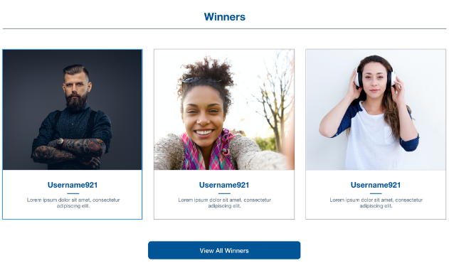

* + - List of winners. Taken from CPA Settings->Winners->Home page winners.
      * Sorted in the same sequence as inside the list **CPA Settings->Winners->Home page winners**;
    - Winner tile:
      * Image. Post->Featured Image;
      * User first and last name. Post->Title;
      * Message. Post->Content.
    - Clicking ‘View all Winners’ opens page ‘Winners’ in the same page.
* Footer:
  + Social links
    - 
    - English version:
      * [Facebook](https://www.facebook.com/canadianpayroll/): <https://www.facebook.com/canadianpayroll/>
      * [Twitter](https://twitter.com/cdnpayroll): <https://twitter.com/cdnpayroll>
      * [LinkedIn](http://www.linkedin.com/company/the-canadian-payroll-association): <http://www.linkedin.com/company/the-canadian-payroll-association>
      * [Youtube](https://www.youtube.com/user/CanadianPayrollAssoc): <https://www.youtube.com/user/CanadianPayrollAssoc>
    - French version:
      * [Facebook](https://www.facebook.com/canadianpayroll/): <https://www.facebook.com/canadianpayroll/> [Open Issue: waiting from client FR version of their Facebook on July 30];
      * Twitter: <https://twitter.com/paiecdn>
      * LinkedIn: <https://www.linkedin.com/company/l-association-canadienne-de-la-paie>
      * [Youtube](https://www.youtube.com/user/CanadianPayrollAssoc): <https://www.youtube.com/user/CanadianPayrollAssoc> [confirmed by client - the same as EN]
  + CPA Logo. Opens <https://www.payroll.ca/> in a new window;
    - 
  + List of who is online. Available for logged in and not logged in users. When people click user names in this section then User Profile opens, which may look like this (for illustration only):

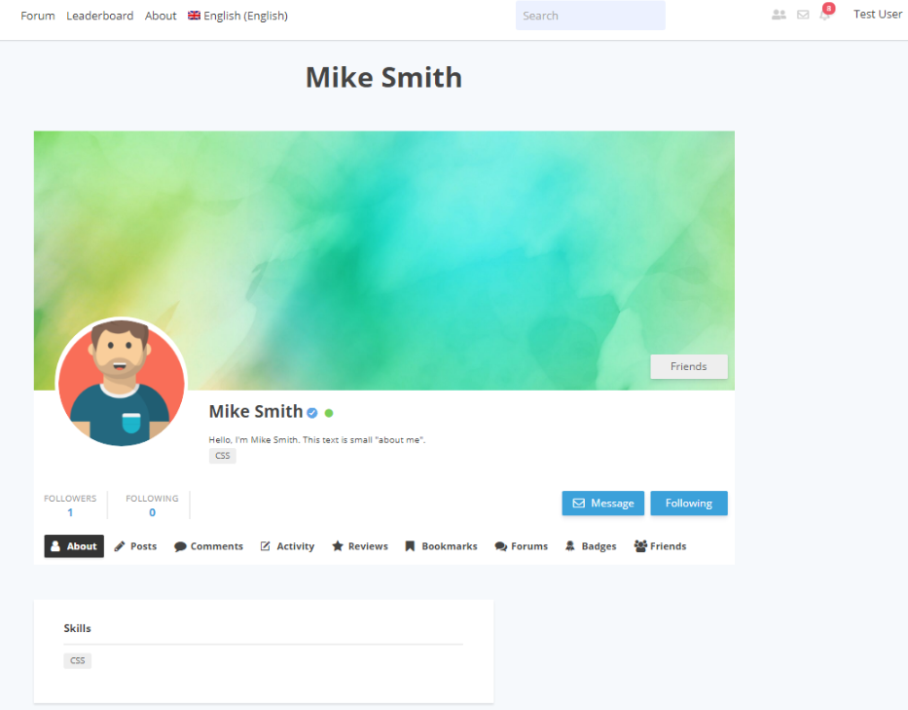

## Page ‘Home’

Landing page for the website after Aug 15.

This page may look like this (included into the Main template).

**Not Logged In** use Home page view:

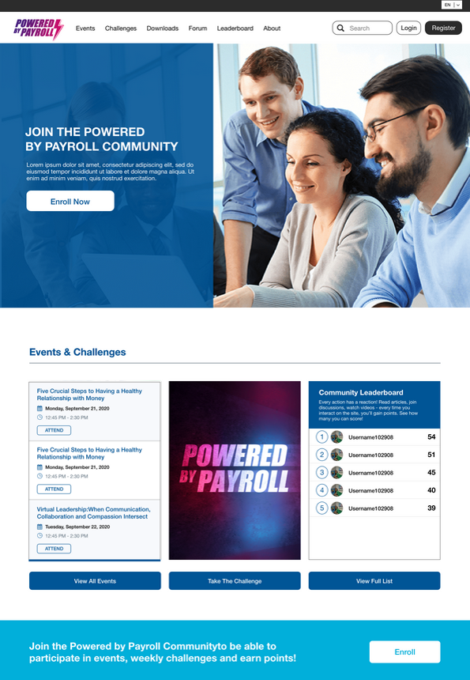

[Bottom part of the page is the same as on the Main template from ‘Sponsors’ till Footer]

**Logged in user** Home page view:

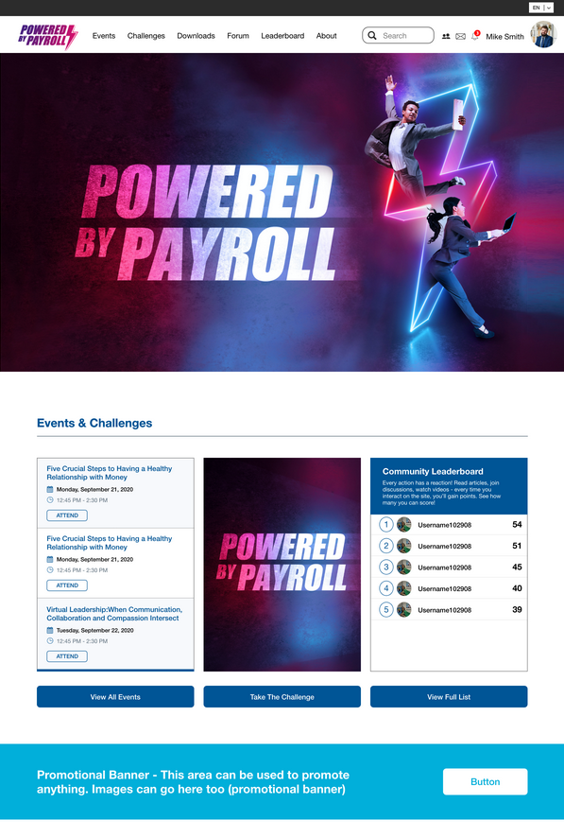

Controls description:

* Content which depends on logged in status:
  + Sections:
    - Top banner
    - Band with join section
  + Clicking ‘*Enroll Now*’ or ‘*Enroll*’ opens page ‘Enroll’ in the same window.
  + [Tech Note: banners and content blocks can be hide/shown for logged in/out user using these shortcodes]

|  |
| --- |
| [um_loggedin] Content only be seen by logged in users [/um_loggedin]  [um_loggedout] Content only be seen by logged out users [/um_loggedout] |

* Section ‘Event Calendar’. The same as described in the Main template->Section ‘Event Calendar’;
* Section ‘Challenge’:
  + Display the first (by a sequence order from repeater) **Active** tile with location = ‘*Home Page*’ from **CPA Settings->Challenges**

[Open Issue: if this is a section where the current challenge is displayed, then please provide images for all challenges. But I recommend to display here a single standard image for all challenges => Angelina will follow up with client. With Angelina: <https://app.asana.com/0/1181397601364668/1183792093369221>];

* + - Clicking an image or button does the following:
      * If user is NOT **Logged In**, then open Log In page in the same window *AND with the same language as the current page*;
      * If user is **Logged In**, then open **CPA Settings->Challenges****->Open Page URL** in the same window;
    - [Jul 3, 20202 this image can be updated manually on the Home page – by Sam. Possible we can do it via Settings]
* Section ‘Leaderboard’. The same as described in the Main template->Section ‘Leaderboard’.

## Page ‘Log In’

Users have to log in to participate in the campaign (see User permissions).

This page may look like this:  
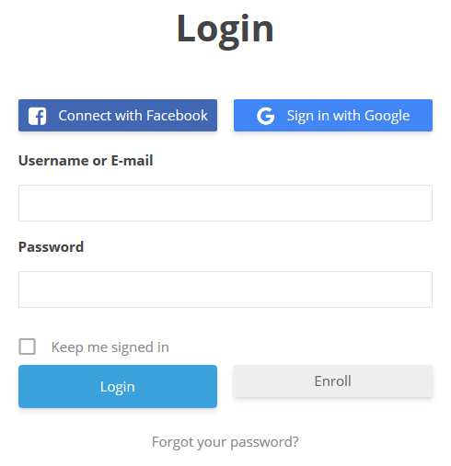

This page should be in English and French. [Open Issue: please check and provide FR translation for Login page: <https://app.asana.com/0/1181397601364668/1184168805982554> ];

* Default English

|  |  |
| --- | --- |
| **EN Name** | **FR Name**  [PM via Google translate ☺] |
| Login | S'identifier |
| Connect with Facebook | Connecter avec Facebook |
| Sign in with Google | Connectez-vous avec Google |
| Username or Email | Nom d'utilisateur ou email |
| Password | Mot de passe |
| Enroll | Inscrire |
| Forgot your password? | Mot de passe oublié? |

**Forgot password notification:** [Open Issue: Let me know if you wish to add FR version for EN email. If yes, please provide FR version for SL and BODY. With Angelina: <https://app.asana.com/0/1181397601364668/1183792093369224>]

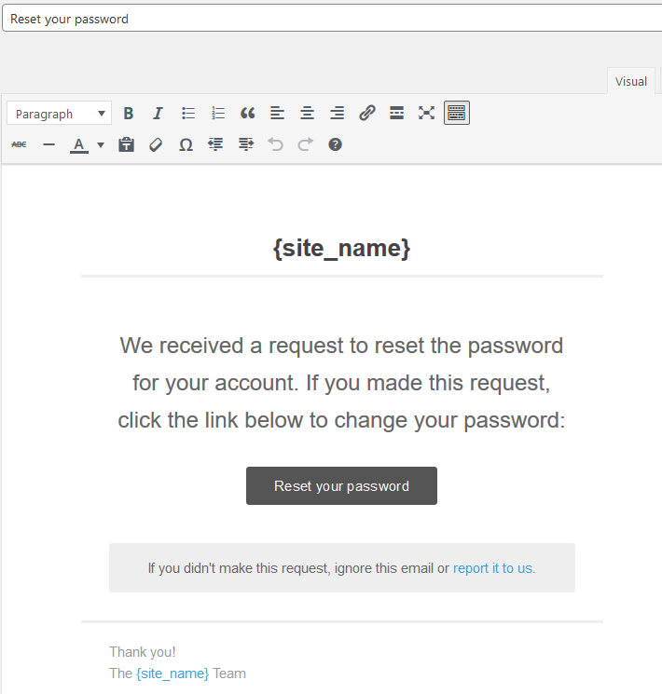

## Page ‘Enroll’

Users have to register to participate in the campaign (see User permissions).

This page may look like this:  
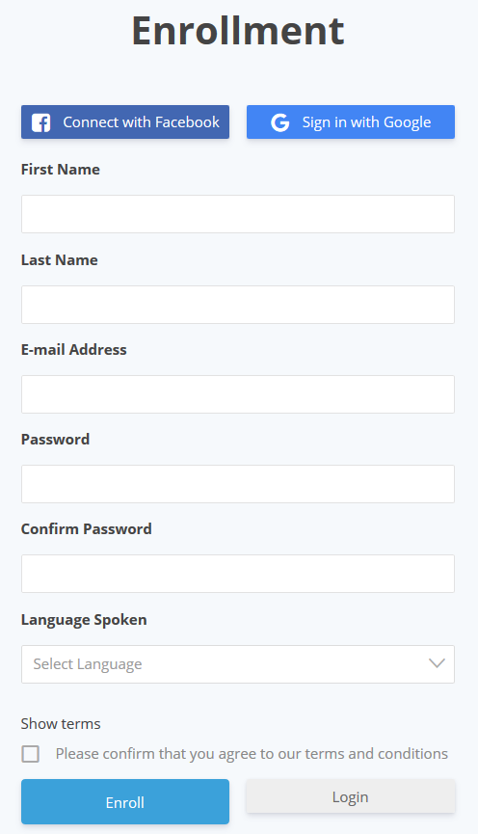

This page should be in English and French. [Open Issue: please check and provide FR translation for Enroll page: <https://app.asana.com/0/1181397601364668/1184168805982558>];

* Default English

|  |  |
| --- | --- |
| **EN Name** | **FR Name**  [PM via Google translate ☺] |
| Enrollment | Inscription |
| Connect with Facebook | Connecter avec Facebook |
| Sign in with Google | Connectez-vous avec Google |
| E-mail Address | Adresse électronique |
| Password | Mot de passe |
| Confirm Password | Confirmez le mot de passe |
| Language Spoken | Langue parlée |
| Show terms | Afficher les termes |
| Please confirm that you agree to our terms and conditions | Veuillez confirmer que vous acceptez nos conditions générales |
| Enroll | Inscrire |
| Login | S'identifier |

Controls description:

* Language Spoken. [Dev Note Jul 11: lets hide this field from this form and automatically save user language into existing custom field in user profile based on the current website language]
  + Drop-down with two options: English and French
  + Mandatory
  + ‘Select Language’ is by default;
* Show terms.
  + [Jul 3, 2020, confirmed by Sam] open a content from page ‘Terms and Conditions’.

[Tech Note: use profile activation via email confirmation workflow for registration if it is not a social registration]

[Tech Note: social logins instructions:

* Google: <https://docs.ultimatemember.com/article/141-social-login-google-app-setup>
* FB: <https://docs.ultimatemember.com/article/20-social-login-facebook-app-setup> ]

[NEXT VERSION: add LinekdIn social connect. Sam confirmed to add if we have time]

Workflow:

* After clicking Enroll the following happens:
  + Page that notices about account activation. It will be in EN only, not depends on user Language

|  |
| --- |
| **Enrollment**  Thank you for registering. Before you can login we need you to activate your account by clicking the activation link in the email we just sent you. |

* + Email with an activation link [Open Issue: please provide FR SL and Body. With Angelina: <https://app.asana.com/0/1181397601364668/1183792093369227>];

[PM: ‘Contact Us’ section - add manually (because only one field in plugin) into emails or remove at all – from Angelina:

Contact emails in EN and FR:

npw@payroll.ca and snp@paie.ca]

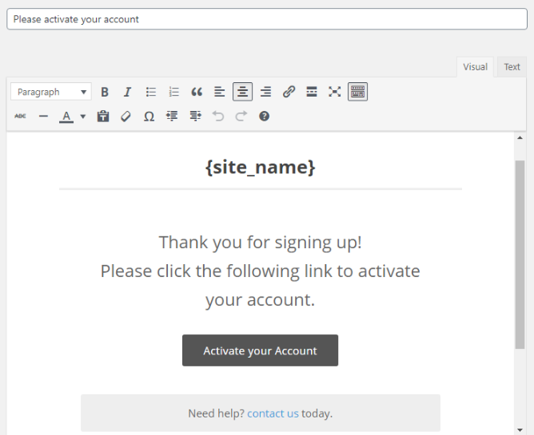

* + This is a page after user activates account:

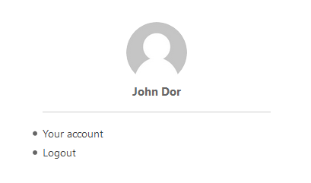

* + This is Welcome email after user activates account: [Open Issue: should it include both versions EN and FR? If Yes, please provide FR SL and Body] [Open Issue: what email should be in the ‘contact at’ link? Can I use my email here: [sergeyp@senseimarketing.com](mailto:sergeyp@senseimarketing.com)? With Angelina: <https://app.asana.com/0/1181397601364668/1183792093369230>]

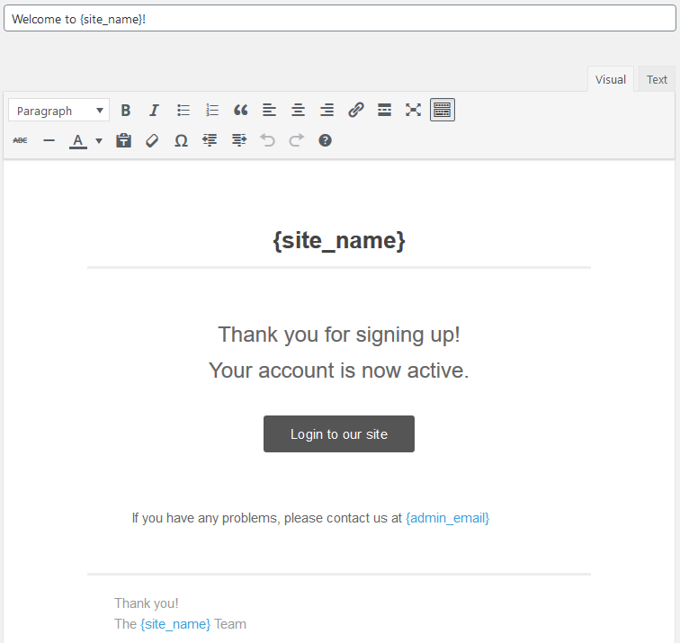

[PM: check social steps for FR/EN versions]

[PM: check and describe these social steps

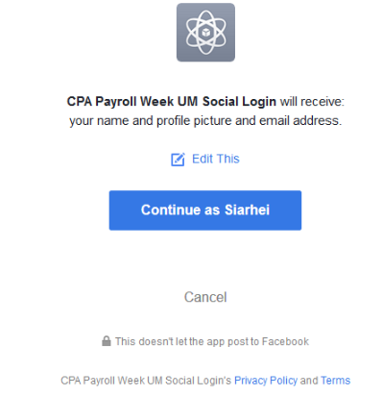

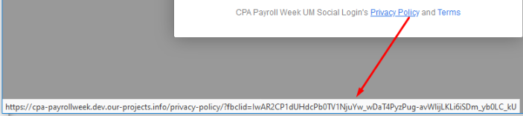

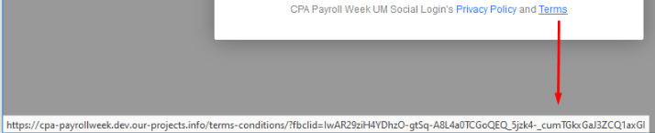

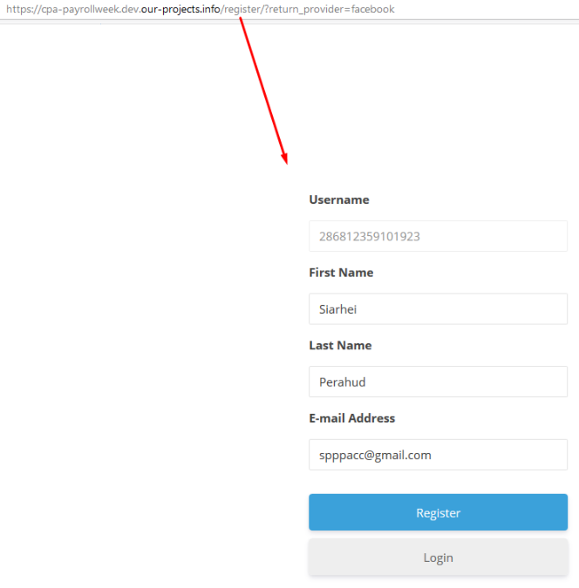

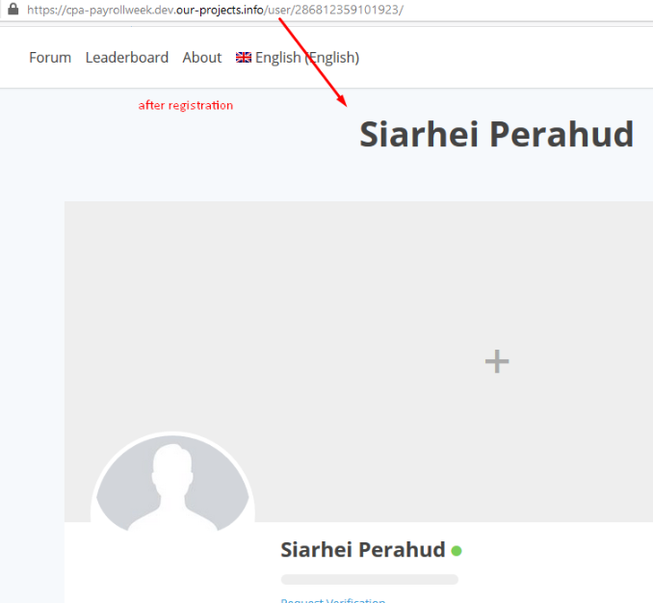

]

## Page ‘Profile’

Requirements:

* Features:
  + Hide/deactivate the following features:
    - **Messages**, **Reviews**, **Bookmarks**, **Private Content**, **Friends**, Member directory, **Followers, Following**, **Tags**, **Verified User**, **Groups, Private Messages, Posts, Comments**
  + Leave active:
    - ~~Comments~~ [Jun 3, 2020: this website will not have posts and comments. This is why it should be hidden];
    - About
    - Activity
    - Badges
    - Forums
* Profile Fields
  + First Name
  + Last Name
  + Email Address
  + Cover Image;
  + Avatar;
  + ~~Short Description (About Me)~~ [Tech Note: cannot use this file for profile completeness];
  + Language Preference (English / French)
    - Required: yes
    - Privacy: Only visible to profile owners and admins
    - Visibility: View everywhere (edit and view mode)
  + Phone (needed for contest)
    - Required: no
    - Privacy: Only visible to profile owners and admins
    - Visibility: View everywhere (edit and view mode)
    - Hint: ‘*Phone numbers may be used to alert challenge winners.*’;
  + Company Name
    - Required: no
    - Privacy: Only visible to profile owners and admins
    - Visibility: View everywhere (edit and view mode)
  + Job Title
    - Required: no
    - Privacy: Only visible to profile owners and admins
    - Visibility: View everywhere (edit and view mode)
  + CPA Member? Yes or No.
    - Required: no
    - Privacy: Only visible to profile owners and admins
    - Visibility: View everywhere (edit and view mode)
    - Default: No

### Profile Completeness

Include all fields from [Profile Fields] above into this feature.

## Events

[Jul 8, 2020 updated]

Full list events with thumbnails:  
<https://docs.google.com/spreadsheets/d/1SSceAFHqu76owdUnfrjhdFLoebtp7Xrr-LVpAAMpK-w/edit#gid=1654654193>

Events thumbnails:

<https://drive.google.com/open?id=1cm2A-ZCoNqN3hfrMyBEDNrP8NqbySsaq&authuser=angelina%40senseimarketing.com&usp=drive_fs>

[Open Issue: please complete list of events: <https://app.asana.com/0/1181397601364668/1183792093369241>]

[Open Issue to Laura: prepare images for events based on your mockup and original images from a client: <https://app.asana.com/0/search/1184198397898184/1184198397898194>]

### Page ‘Events’

Lists of events.

* It is planned to have up to 7 pre-defined events on the website.

This page may look like this (included into the Main template)

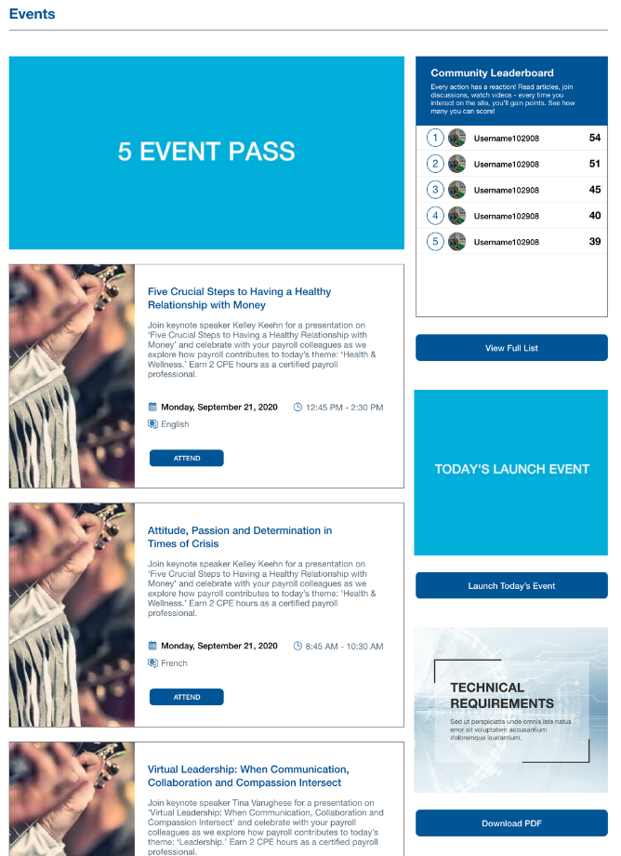

Controls description:

* Banner. This page will have an individual banner, different then a banner on other pages;
*  - this is an image with static URL

[Open Issue to Angelina: please provide this image and URL <https://app.asana.com/0/1181397601364668/1183977740274372>];

[Open Issue to Angelina: Will this be available to not logged in user as well? <https://app.asana.com/0/1181397601364668/1184156465417093>];

* List of events;
  + [Open Issue: <https://app.asana.com/0/1181397601364668/1184156465417085>
    - Should passed events be displayed here?
      * If not – what should be displayed when all events passed? For simplicity I would recommend to display all events here – passed and not passed.
    - Do we need to display Attend button for passed events?
      * If not – what should be here – no button?];
  + Sorted by [**Event Start Date/time**] in ascending order – most current at the top. Always display all events passed and not passed.
  + Items:
    - Thumbnail. Post->featured Image;
    - Title. Post->title;
    - Date. Post->Event Start Date/time – date part only in format as on the mockup;
    - Time. Post-> Duration;
    - Language. Post->Language;
    - Short description. Post->Content;
    - ‘Attend’ action.
      * If user is NOT **Logged In**, then open Log In page in the same window *AND with the same language as the current page*;
      * If user is **Logged In**, then Post->Registration Link to be opened in a new tab.
* Section ‘Launch Today’s Event’. This will include a constant 3rd party URL for all days and events;



* + Clicking button: [Jul 11, 2020: client decided to use only button without an image] [Open Issue: provide image and URL: <https://app.asana.com/0/1181397601364668/1183977740274376>]
    - If user is NOT **Logged In**, then open Log In page in the same window *AND with the same language as the current page*;
    - If user is **Logged In**, then a static URL in a new tab.
* Clicking ‘Tech requirements’ image or button will open in new tab a static link (I think it will be PDF on our hosting).

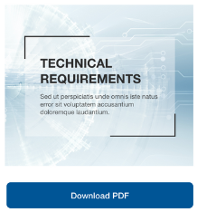

[Open Issue: provide image: <https://app.asana.com/0/1181397601364668/1183977740274380>];

* + [Tech Note: upload PDF file into project from this folder:

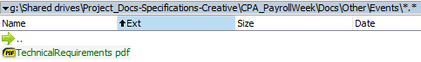]

* Section ‘Leaderboard’
  + The same as described on the Main template.

## Challenges

Source list of challenges

<https://docs.google.com/spreadsheets/d/1SSceAFHqu76owdUnfrjhdFLoebtp7Xrr-LVpAAMpK-w/edit#gid=556296201>

[Open Issue to Angelina: do we have list of challenges: Name EN/FR, thumbnail EN/FR, description EN/FR, type (challenge or share response), date. With Angelina: <https://app.asana.com/0/1181397601364668/1183792093369245>]

**Source files for challenges** [Jul 11, 2020 managed by Angelina]**:**

\Shared drives\Project_Docs-Specifications-Creative\CPA_PayrollWeek\Docs\Other\Deliverables from CPA - EN\Images\Challenges\

[Jul 2, 20202 updated]

|  |
| --- |
| **Weekly challenges**   * Every Monday starting August 9- September 14 (6 challenges total) * Each weekly challenge opens Monday at 10am EST, closes Sunday at 11:59pm * Each weekly challenge worth 50 points toward Payroll Powerhouse award * Each weekly challenge requires “larger ask” (e.g. send video clip, photo, story, etc.) * Each weekly challenge eligible for weekly prize draw, winner announced following Monday * Total points available for completing weekly challenges = 300   **One-Day Challenges**   * Every Thursday starting August 6- September 17 (7 total) * Each daily challenge opens Thursday at 10am EST, closes Thursday 11:59pm EST * Each daily challenge worth X points toward Payroll Powerhouse award   + Refer to “Points/Leaderboard” tab on spreadsheet for official point allocation and rules. Anything in the wireframes is just for illustration purposes. <https://docs.google.com/spreadsheets/d/1SSceAFHqu76owdUnfrjhdFLoebtp7Xrr-LVpAAMpK-w/edit#gid=1034063564> * Each weekly challenge requires “engagement activity” (e.g. share post, tweet with hashtag, answer question or trivia, etc.) * ~~Total points available for completing daily challenges = 210~~ * Extra small prizes available if needed   **Daily NPW Challenges**   * Issued daily during week of NPW (Sep 21-24) (6 challenges total); two on Tuesday and Thursday   + Weekly challenges posted every Monday, open from Monday morning till Sunday night. Daily Challenges are open 24 hours and opened every Thursday morning till Thursday midnight. NPW challenges are the same as daily challenges BUT occur every day during National Payroll Week (Monday Sep 21 to Friday Sep 25). Please see calendar in Google Drive we shared with you for when all the challenges are scheduled * Each challenge issued at 10am * Each daily challenge worth X points toward Payroll Powerhouse award   + Refer to “Points/Leaderboard” tab on spreadsheet for official point allocation and rules. Anything in the wireframes is just for illustration purposes. <https://docs.google.com/spreadsheets/d/1SSceAFHqu76owdUnfrjhdFLoebtp7Xrr-LVpAAMpK-w/edit#gid=1034063564> * Each daily challenge requires “engagement activity” (e.g. share post, tweet with hashtag, answer question or trivia, etc.) * ~~Total points available for completing daily challenges = 240~~ * Extra small prizes available if needed   **Other:**   * If more than one person has highest score achievable, Payroll Powerhouse Award given to person who…(1) either completed challenges first, or (2) was selected as daily prize winner?   + [SF: All winners are chosen manually. NO coding required] * Sharing resources, downloading materials, and taking part in discussion forums = X points each (unlimited)   + [SF: Please refer to the spreadsheet we have previously provided for official points and rules for each, including badges. >> <https://docs.google.com/spreadsheets/d/1SSceAFHqu76owdUnfrjhdFLoebtp7Xrr-LVpAAMpK-w/edit#gid=1034063564> ] * Participants must register through the NPW microsite to play   + [SF: NWP is “National Payroll Week”, which is the site we are developing. ]   Every challenge entry would have a corresponding CSR   * [SF: The client is giving away money to a charity (Dress for Success) for every challenge completed. We do not need to do anything here. No coding. It’s all done manually on their end. They will make this calculation based on the files we give them at the end of each challenge period (the people and responses to that challenge)] * Weekly $5, daily $1 |
|  |

### Page ‘Challenges’

List of available challenges:

* Types of challenges:
  + Post a response
  + Share response. [PM: to apply this need to follow these procedures:
    - Admin adds a response under PA Admin user, with right image and text for this challenge;
    - Admin selects this response as source for challenge on a website];
* Duration:
  + Weekly – duration is a week
  + Daily / NWP Daily – duration is a day. This is the same type of challenges, but they will be in different periods
* Rules:
  + Each user can participate in each challenge just once.

This page may look like this, for illustration only (included into the Main template):

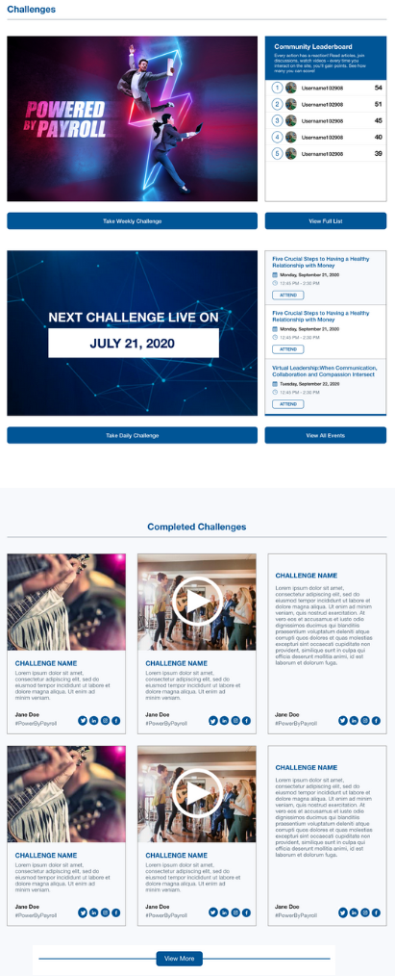

Controls description:

|  |
| --- |
| **Section ‘Active Challenges’**   * Display list of blocks (image + text + button) from **CPA Settings->Challenges**   + Display tiles with location = ‘*Challenges Page*’ in the same sort order as in the repeater   + Clicking an image or button does the following:     - If user is NOT **Logged In**, then open Log In page in the same window *AND with the same language as the current page*;     - If user is **Logged In**, then open **CPA Settings->Challenges****->Open Page URL** in the same window; |
| Section ‘*Leaderboard*’ and ‘*Events*’ are the same as on the Home page. |
| **Section** ‘**Completed Challenges**’   * This section displays recent 9 responses and a button ‘**View More**’. * - should be hidden if there are no responses.   Clicking ‘View More’ add additional 9 recent responses at the end of the lists   * ‘View More’ can maximum open 198 responses. * This button should be disappeared if there are no to view responses, or if 198 responses are already opened.   Challenge block should look like this:   * See fields description and tile behaviour in the chapter ‘Response Details’;   + Exception:     - Social icons are inside the tile, not outside  |  |  |  | | --- | --- | --- | | **Text only** | **Text + Image** | **Text + Video** | |

#### Page ‘Post a Response’

Using this page users can add a response to a challenge.

When page opens then:

* If user is NOT **Logged In**, then open Log In page in the same window *AND with the same language as the current page*; [Tech Note: this may happen when user saved a direct link on this response and opens it in a new session where he is not logged in];
* If user is **Logged In**, then open this page described below.

This page may look like this (for illustration only):

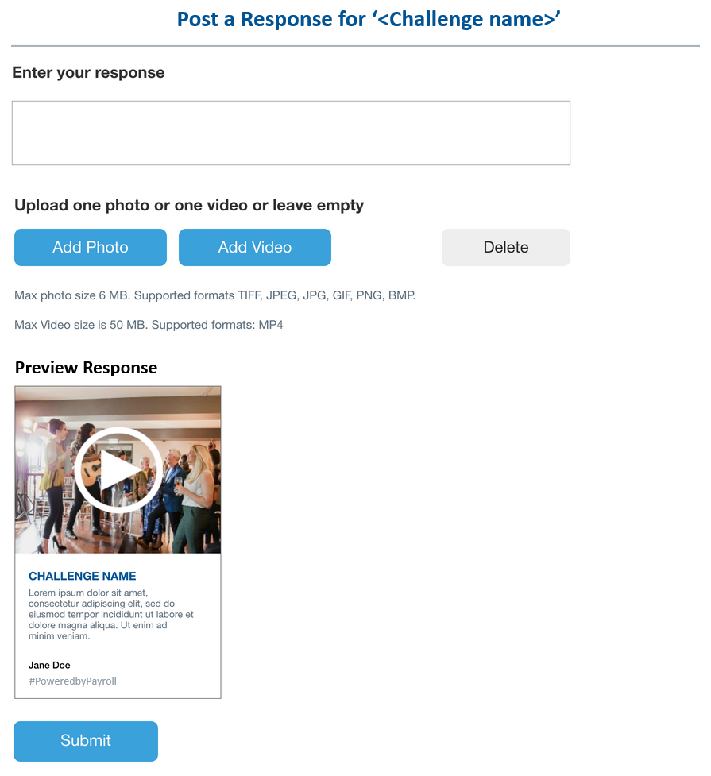

[Open Issue: waiting translation: <https://app.asana.com/0/1181397601364668/1184198397898157>]

Controls description:

* Challenge Name. Challenge name for this response;
* Enter your response.
  + This is text area, max 500 chars. Do not allow to enter more than 500 chars;
  + Empty by default;
  + Mandatory;
* Photo / Video section [Dev Note: discussed with Andrei: save and convert video on CDN, save and make thumbnail immediately after download, use Youtube API for saving videos (without recommended section), view image and video via admin panel in response];
  + ‘Delete’ button.
    - Hidden by default;
    - It is only displayed when photo or video is added into preview section.
* ‘Preview Response’ section.
  + This section should preview a response tile. Tile fields are described in the chapter ‘Response Details’;
    - Challenge Name. Challenge name for this response;
    - This tile should not include date/time or share buttons in the bottom right corner;
    - Text / image / video automatically changed once user types or adds/deletes them;
  + Only one photo or one video can be loaded for a response. If user adds another video or photo, then the previous one (if it was) is replaced.

Clicking ‘*Add Photo*’ button does the following:

* Opens a standard Open File dialog box to select an image
* Once image selected then:
  + If image type is not [TIFF, JPEG, JPG, GIF, PNG, BMP] then display an error message below the title saying:

|  |  |
| --- | --- |
| **English** | *Please upload an image in one of these formats: TIFF, JPEG, JPG, GIF, PNG, BMP.* |
| **French** | Veuillez télécharger une image dans l'un de ces formats: TIFF, JPEG, JPG, GIF, PNG, BMP. |

* + If image size is >6Mb then display an error message below the title saying:

|  |  |
| --- | --- |
| **English** | *Image size should be less or equal 6Mb.* |
| **French** | La taille de l'image doit être inférieure ou égale à 6 Mo. |

* + If everything is OK, then:
    - Upload image without reloading page and display it in the [preview section];
      * If [preview section already has an image or video, then they are deleted/replaced automatically];
    - Display ‘Delete’ button.

Clicking ‘*Add Video’* button does the following:

* Opens a standard Open File dialog box to select a video
* Once image selected then:
  + If video type is not [MP4] then display an error message below the title saying: [Dev Note: should we support other formats?]

|  |  |
| --- | --- |
| **English** | *Please upload video in MP4 format only.* |
| **French** | Veuillez télécharger la vidéo au format MP4 uniquement. |

* + If video size is >50Mb then display an error message below the title saying:

|  |  |
| --- | --- |
| **English** | *Video size should be less or equal 50Mb.* |
| **French** | La taille de la vidéo doit être inférieure ou égale à 50 Mo. |

* + If everything is OK, then:
    - Upload video without reloading page and display it in the [preview section];
      * If [preview section already has an image or video, then they are deleted/replaced automatically];
    - Display ‘Delete’ button.

Clicking ‘*Delete*’ button:

* Deleted image or video from the [preview section] and hides ‘Delete’ button
  + Do not display any confirmation messages.

Clicking ‘Submit’ button does the following:

1. If response text is not provided [Tech Note: trim spaces before checking], then display an error message below the title saying:

|  |  |
| --- | --- |
| **English** | *Please enter your response.* |
| **French** | Veuillez entrer votre réponse. |

1. If any unexpected error occurred, then display an error message below the title saying:

|  |  |
| --- | --- |
| **English** | *Operation failed, please try again later.* |
| **French** | L'opération a échoué, veuillez réessayer plus tard. |

1. If all is OK, then:
   1. Create a new response with fields:
      1. Response URL = <main domain>/responses/<a new post id>;
      2. Response title = <challenge name>
      3. Response content = <response text> [Tech Note: take only the first 2000 chars from the entered content. This should prevent from situations when someone enters > 2k chars];
      4. Response image = <uploaded image> or <first frame from video> or nothing.
         1. Image should be scaled using the following rules:

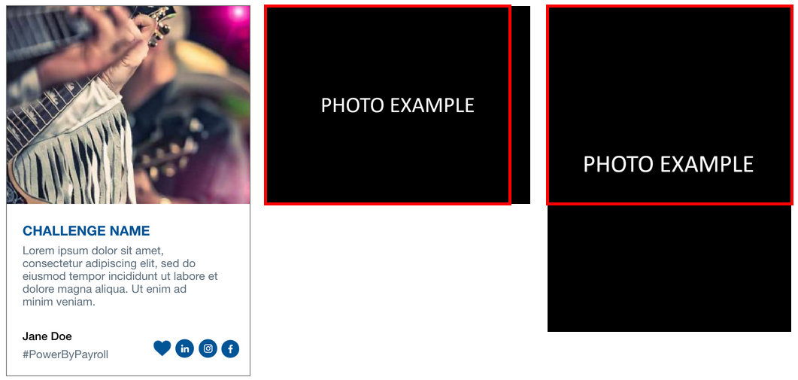

* + - * 1. If image width > image height, then scale in/out image height to 493px;
        2. If image width <= image height, then scale in/out image width to 325px;
    1. Response video = <uploaded video> or nothing [Dev Note: use CDN to automatically process and compress video files. Example: SWARNIFY];
    2. Response user = <logged in user>
    3. Challenge reference = <this link on a challenge post>
    4. Date/time = date/time when it was created.
  1. Open ‘Response Details’ page in the same window.

#### Page ‘Response Details’

This page displays submitted responses.

It may look like this, based on what type of details was submitted (included into the Main template)

* ***NOTE:*** *include into main template to be sure that when people visit this page then they can see other sections on the website [Jul 8, 2020 confirmed by Angelina];*

|  |  |  |
| --- | --- | --- |
| **Only text submitted** | **Text and Image submitted** | **Text and video submitted** |

When this page is opened from ‘Post a Response’ page then display the following message at the top of the page ‘*Thank you for your submission!*’

* Example:

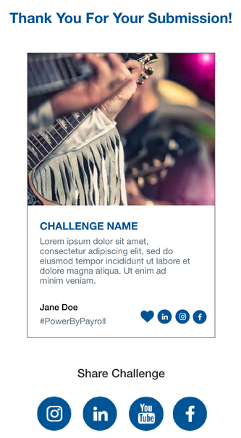

Controls description:

* Challenge Name. This is challenge name of this response (it can be a Response->Title);
  + Yes, all responses will have the same title, for a similar challenge
* Content. This is a response->Content;
* Image. This is a Response->Image, if it was provided;
  + If this tile has a video, then display [a play button] above the image
    - Clicking this image will open a popup ‘Play Video’.
* User Name. This is first and last name of user who submitted this response;
* ‘**#PoweredbyPayroll**’ – static text, can be changed in future [Jul 8, 2020 confirmed by client]; [Testing Note: This hashtag should be used on all pages. creative in Zeplin is invalid];
* [Date/Time]. Date / time when it was posted in EST timezone [Tech Note: server may work by GMT];
  + Date Format: MMM D
  + Time Format: HH:MMPM/AM
* Share Challenge.
  + List of social networks [Tech Note: not logged in users can share responses, but they will not receive points] [Open issue: is this list correct? YouTube share? Maybe it was Twitter? With Angelina <https://app.asana.com/0/1181397601364668/1183805721266685>];
    - Pinterest
    - LinkedIn
    - ~~YouTube~~
    - Facebook
    - Twitter
  + The following content should be shared [Open Issue: please provide a format for sharing message. Rules how to generate default message for sharing. With Angelina – the same case as above].
    - Metatags details:

|  |
| --- |
| <meta property="og:title" content="<challenge name>"/>  <meta property="og:description" content="<up to 280 chars from Response->Content>"/>  <meta property="og:site_name" content="<website name from Settings>"/>  <meta property="og:url" content="<full path URL on this response>"/>  <meta property="og:image" content="<full path URL to [image]>"/>   * If response has [image], this this is path to response->Image * If response has [video], this is path on the response->video first frame (cover image) * If response does not have image or video, the this is challenge->featured image   + If challenge does not have a featured image, then leave it empty   <meta property="twitter:card" content="summary_large_image"/>  <meta property="twitter:title" content="<challenge name>"/>  <meta property="twitter:image" content="<full path URL to [images] as for **og:image**>"/>  <meta property="twitter:description" content="<up to 130 chars from Response->Content>"/>  <meta property="twitter:url" content="<full path URL on this response>"/>  <meta property="twitter:creator" content="@cdnpayroll"/> |

[Open Issue: do we need comments for responses? It was not in the scope, but probably we can add it easily after all other is completed. What do you think? With Angelina <https://app.asana.com/0/1181397601364668/1183805721266689>]

##### Popup ‘Play Video’

This popup is used to play response video

It may look like this (for illustration only)

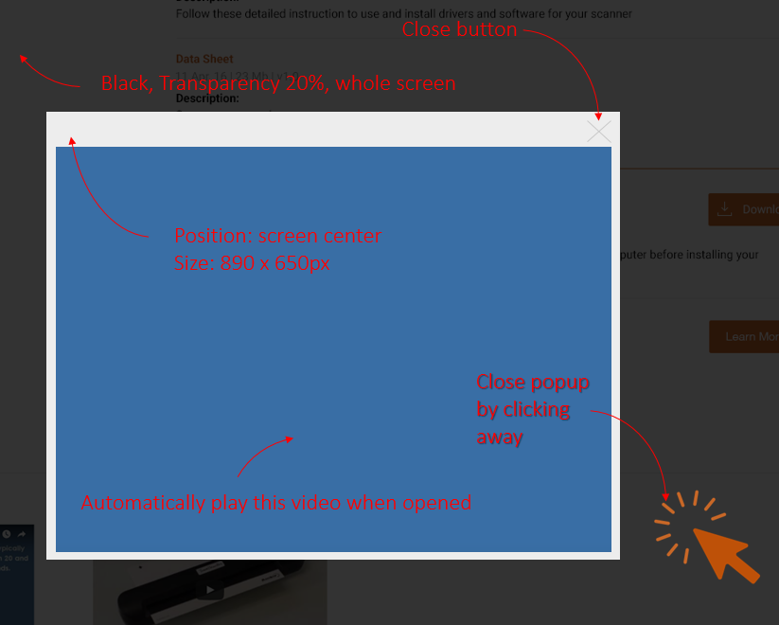

Controls description:

* This is a Response->Video, if it was provided;

## Page ‘Downloads’

List of available downloads:

* There are will be ~15 items only
* File format: PDF and images

[Open Issue: please provide full list of downloads EN/FR: thumbnail, title, description, actual image or PDF. With Angelina: <https://app.asana.com/0/1181397601364668/1183805721266693>]

This page may look like this (included into the Main template):

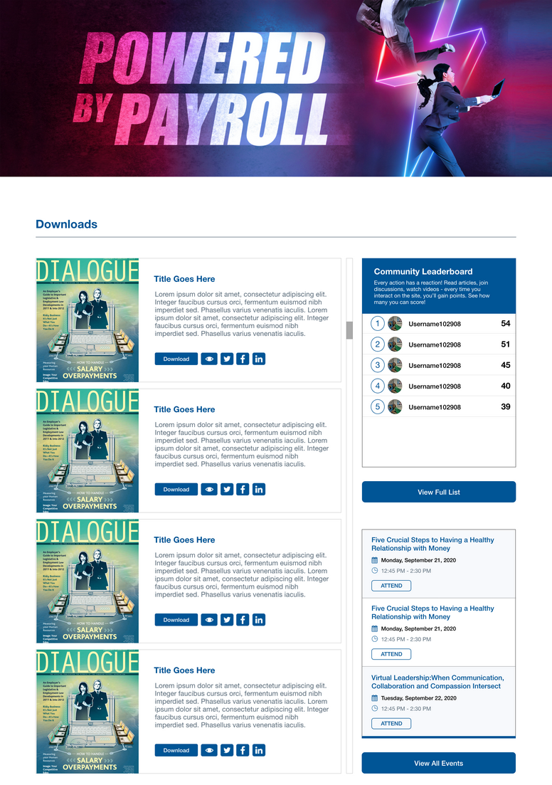

Controls description:

* Banner. This page will have an individual banner, different then a banner on other pages;
* List of downloads. Managed via Admin->Downloads;
  + Sorted by [Published] in descending order – recently added at the top
  + Display all items without any pagination and ignore [Tech Note: internal scrolling for downloads on creative above];
  + Download items:
    - Thumbnail. This is Post->Featured Image;
    - Title. This is Post->Title. Opens page ‘Download Details’ in the same window;
    - Description. This is Post->Content;
  + Actions:
    -  Share. Allow to share downloads directly from this list.
      * Social networks: LinkedIn, Twitter, Facebook [Jul 11, 2020: list confirmed by Angelina];
      * Meta details provided below.

[Tech Note: allow to share downloads for not logged in user, but they will not receive points];

[Tech Note: ‘Instagram’ icon was removed from the share because Instagram does not support sharing from web sites];

* + -  View. Opens page ‘Download Details’ in the same window;
    -  ‘Download’ action:
      * If user is NOT **Logged In**, then open Log In page in the same window *AND with the same language as the current page*;
      * If user is **Logged In**, then download item like a regular file in a browser;
* Side bar:
  + Section ‘*Leaderboard*’. The same as described on the Home page;
  + Section ‘*Event Calendar*’. The same as described on the Home page;

Metatags details:

|  |
| --- |
| <meta property="og:title" content="<Post->Title>"/>  <meta property="og:description" content="<up to 280 chars from Post->Content>"/>  <meta property="og:site_name" content="<website name from Settings>"/>  <meta property="og:url" content="<full path URL on this post>"/>  <meta property="og:image" content="<full path URL to Post->Featured Image>"/>  <meta property="twitter:card" content="summary_large_image"/>  <meta property="twitter:title" content="<Post->Title>"/>  <meta property="twitter:image" content="<the same as **og:image**>"/>  <meta property="twitter:description" content="<up to 130 chars from Post->Content>"/>  <meta property="twitter:url" content="<full path URL on this post>"/>  <meta property="twitter:creator" content="@cdnpayroll"/> [Jul 11, 2020: confirmed by Angelina] |

### Page ‘Download Details’

This is page for individual download for sharing purposes.

This page may look like this (included into the Main template with sidebar and bottom sections):

* Exception:
  + NO Top Banner

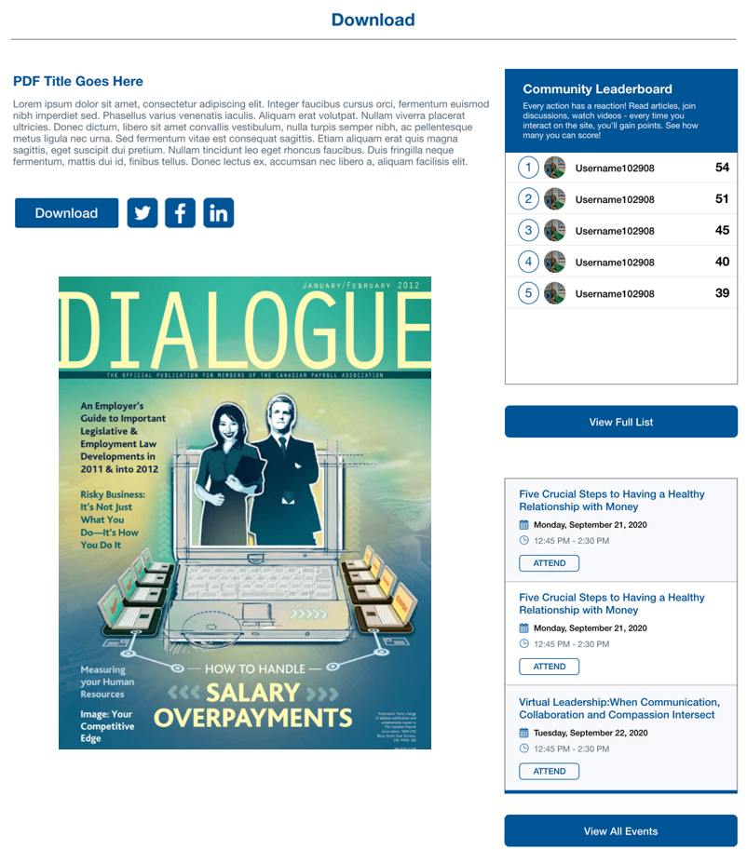

Controls description:

* Section ‘Download’
  + Title, Description, ‘Download’ button and Social icons – the same as on the page ‘Downloads’,
  + Preview. This is Post->File
    - For images: display an image, not clickable;
    - For PDF: display PDF in special preview control.

[Tech Note: I decided do not add navigation here, but if to add it then it may look like on ECHO for articles]

## Page ‘Forum’

Forum will not be a Multilanguage, one forum for EN and FR content [Jun 29, 2020 confirmed by Sam].

Default forum and questions: <https://app.asana.com/0/1181397601364668/1182801515264891>

|  |
| --- |
| **1. Building Your Payroll Career**  a. What are the most valuable steps you have taken to build your payroll career?  b. Why is payroll a rewarding career choice?  **2. The Contribution of Payroll**  a. How does payroll support employee financial wellness?  b. What can payroll do strategically to help businesses thrive?  **3. The Future of Payroll**  a. How will payroll change in the next five years?  b. What changes would you like to see in payroll in the future? |

[Jul 10, 2020: icons ready in project folder https://app.asana.com/0/1170612484660730/1183913357557730]

[Tech Note: replace Forum->Register and Login pages on WP standard Enroll and Login pages]

This page may look like this (included into the Main template)

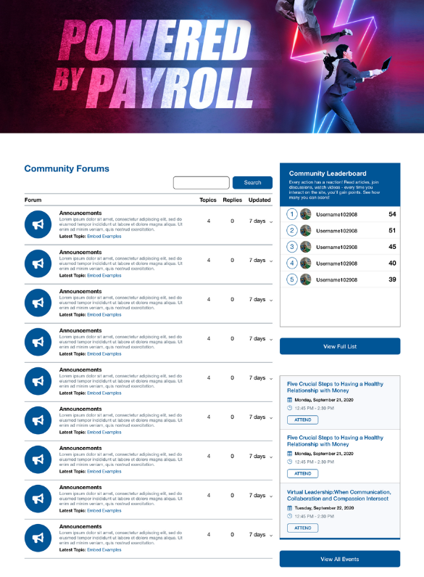

Controls description:

* Banner. This page will have an individual banner, different then a banner on other pages;
* Forum. This is actual forum section with search and add functionality. [Tech Note: possible need to move Leaderboard and Event Calendar below the forum, because it will not have enough space].

## Page ‘Leaderboard’

This page displays list of all users who have at least 1 point.

This page may look like this (included into the Main template):

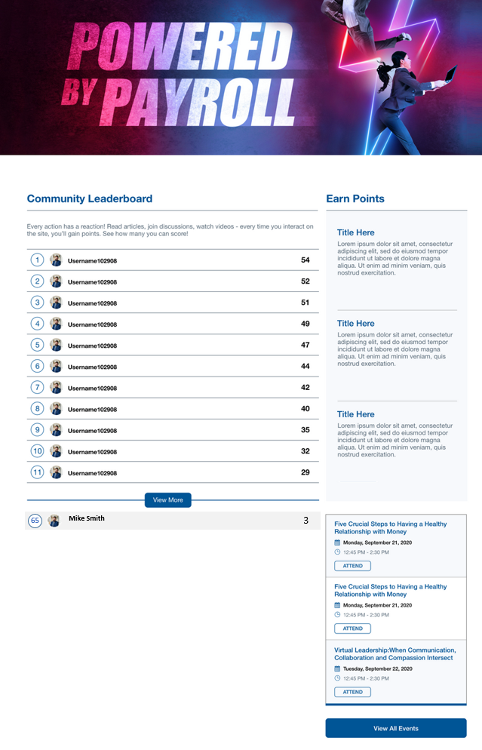

Controls description:

* Banner. This page will have an individual banner, different then a banner on other pages;
* List of users and their points.
  + By default displays first 10 users;
  + Include only users:
    - With Subscriber role only;
    - Who have at least one point. I think all logged in users will have at least one point for log in ☺
  + Each user:
    - Place. Calculated based on user’s points;
    - User avatar. Taken from user’s profile;
    - First and Last name;
    - Points.
* Link ‘View More’
  + Hidden if there are less than 10 users in the list
* Section with a logged in user points (this is a section below [View more] button).
  + ~~Do not display this section if:~~
    - ~~[Update Jun 19, 2018] If user is not Logged In~~
    - ~~If user does not have points.~~
    - ~~User is included into Top 30~~
* Section ‘Earn Points’. Static HTML section [Open Issue: provide copy for this section <https://app.asana.com/0/1181397601364668/1184156465417119>];

Clicking ‘View More’ add additional 10 users at the end of the lists

* Section with a logged in user will be always at the bottom of the list.
* ‘View More’ can maximum open 200 records.

## Winners

Choosing winners:

* During National Payroll Week daily challenges are active (5 days), we need to provide the file every day with users.
  + Client will choose a winner from the data provided and create image of winner to post here

### Page ‘Winners’

This page displays all winners.

This page may look like this (included into Main template)

* No top banner
* No right sidebar
* No bottom sections

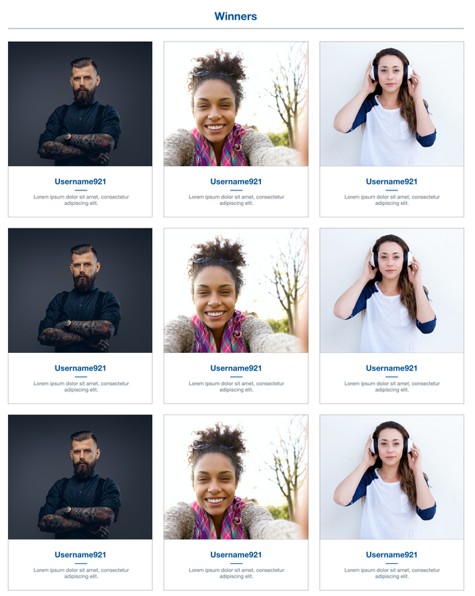

Controls description:

* List of winners.
  + The list will be empty if there are no winners yet;
    - But the section name and horizontal line should present ☺
  + Sorted by Post->Published date/time in descending order. Recently added at the top;
  + It shows all winners without a navigation, because this list will be small ~20-30 people;
  + Profile details are the same as described on the Main template->Winners section.

## Page ‘About’

This is simple HTML page.

It may look like this (included into the Main template) [Open Issue: provide EN and FR copy. With Angelina: <https://app.asana.com/0/1181397601364668/1183805721266701>]

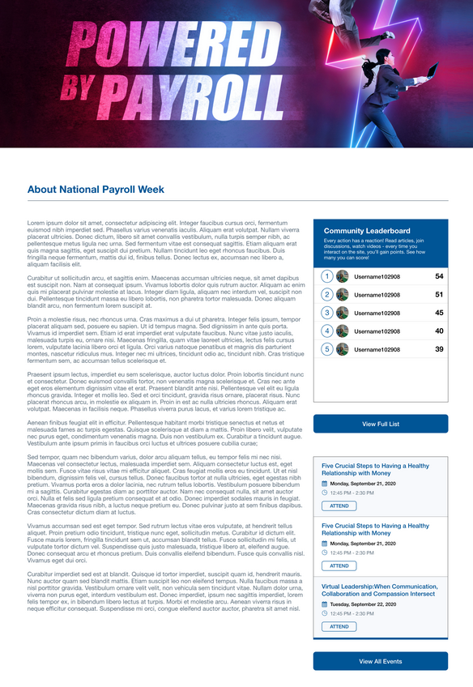

Controls description:

* Banner. This page will have an individual banner, different then a banner on other pages;

## Page ‘Terms and Conditions’

This page should be included into the Main template:

* NO top banner
* NO sidebar
* NO bottom sections

English:

<https://docs.google.com/document/d/1eaTFX7_8_SLs8HRU69Sb81xvU6oTD3u9vHrcA3cxXaI/edit?usp=sharing>

French: [Open Issue: waiting French copy: <https://app.asana.com/0/search/1184198397898184/1183726860918133>]

## Page ‘Privacy Policy’

This page should be included into the Main template:

* NO top banner
* NO sidebar
* NO bottom sections

English:

<https://drive.google.com/open?id=1WH-LkOfXaFrgkaQIazZDkQtVie_BdZ-0&authuser=sergeyp%40senseimarketing.com&usp=drive_fs>

French:

<https://drive.google.com/open?id=1W9_qTfEUzPmp9eXUN8PsAETlkqYhGfmC&authuser=sergeyp%40senseimarketing.com&usp=drive_fs>

Files are here:

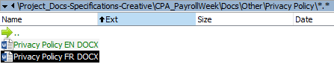

## Page ‘Community Rules’

This page should be included into the Main template:

* NO top banner
* NO sidebar
* NO bottom sections

English and French (in a project folder):

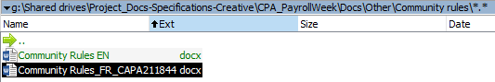

## Page ‘Refer A colleague’

[Jun 30, 2020 from Sam: Open tracking, etc, is not required]

[Jul 2, 2020 copy below updated by Sam]

This a page send invitations and earn ballots.

When page opens then:

* If user is NOT **Logged In**, then open Log In page in the same window *AND with the same language as the current page*;
* If user is **Logged In**, then open this page described below.

This page may look like this (included into Main template):

* NO top banner
* NO sidebar
* NO bottom section

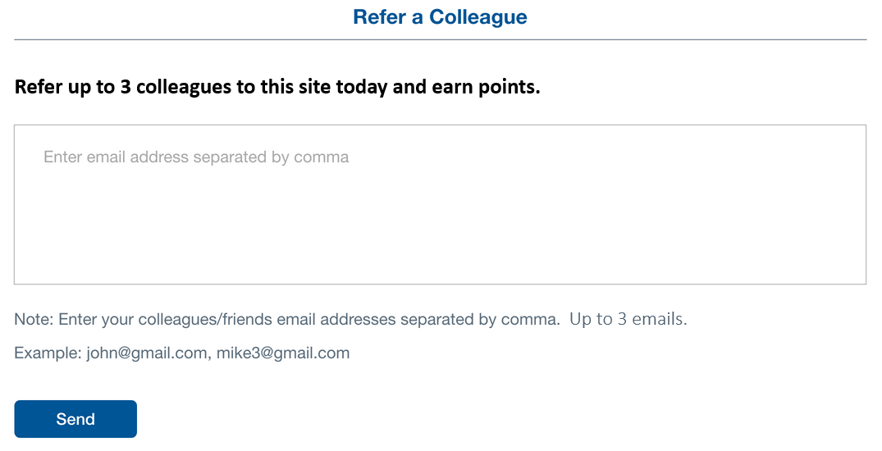

When page opens:

* If user is logged in then:
  + If user already sent at least on email this day, then the following page displays:

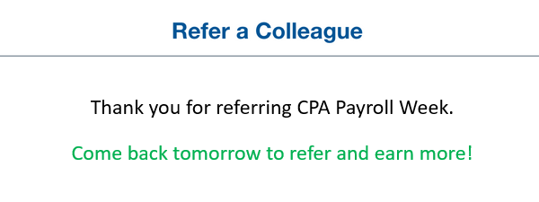

|  |  |
| --- | --- |
| **English** | Thank you for referring CPA Payroll Week.  Come back tomorrow to refer and earn more! |
| **French** | Merci d'avoir parrainé la Semaine de la paie CPA.  Revenez demain pour vous référer et gagner plus! |

Controls description:

* Text area. Placeholder – by default. Max 1000 chars (which is 3 emails * max 320 chars).

Clicking ‘Send’ button does the following:

1. If emails were not provided, then an error message displays below the title saying:

|  |  |
| --- | --- |
| **English** | Please enter email(s) addresses. |
| **French** | Veuillez saisir les adresses e-mail. |

1. If one or more email addresses were provided but at least one is invalid then an error message displays below the title saying ‘Please provide valid e-mail addresses: ‘<invalid email 1>, … < invalid email N>’.’. Emails are pre-populated; [Tech Note: split emails if they are separated by comma (‘,’ or ‘;’ or <ENTER>) and display invalid e-mails only]

|  |  |
| --- | --- |
| **English** | Please provide valid e-mail addresses: ‘<invalid email 1>, … < invalid email N>’. |
| **French** | Veuillez fournir une ou des adresses e-mail valides: ‘<invalid email 1>, … < invalid email N>’. |

1. If emails were provided but there are more than 3 emails, then an error message displays below the title saying: ‘Please enter up to 3 emails.’. Emails are pre-populated;

|  |  |
| --- | --- |
| **English** | Please enter up to 3 emails. |
| **French** | Veuillez saisir jusqu'à 3 e-mails. |

1. If emails were provided and OK, then:
   1. Hide the form;
   2. Show a thank you message as shown above;
   3. Save these emails in **User Profile->Referrals**. [Tech Note: add a ‘Referrals’ as a repeater into User profile with the following columns:
      1. Added Time - date/time control. Shows time when it was added;
      2. Referrals – text area control. List of Emails]
   4. Send **individual emails** to entered email addresses. (Font: Courier New, Size: 10 points) [Open Issue: please provide FR version for Subject Line and Body. With Angelina: <https://app.asana.com/0/1181397601364668/1184168805982566>]

|  |  |
| --- | --- |
| FROM | CPA Payroll Week <DoNotReply@WEBSITE-DOMAIN> |
| TO | <a single email from the list> |
| SUBJECT | <first> <last> has invited to register on CPA Payroll Week web site |
| BODY | Hello  <First Name> <Last Name> has joined the National Payroll Week community site to celebrate payroll professionals and their influence on the success of business.   <First Name> is inviting you to come visit the site, engage other professionals, and possibly in great prizes.  You can check out the community here: <URL>.  Sincerely,  The Community Management Team  <Website domain> |

Where:

* + - <First> and <last> are logged in user first and last names;
    - <URL>. This website Home page URL.
      * For English: <web site domain>
      * For French: <website domain>/fr
    - <website domain>
      * For English: <web site domain>
      * For French: <website domain>/fr

## Page ‘Tell us Your Story’

This page allows logged in users submit stories and get points.

When page opens then:

* If user is NOT **Logged In**, then open Log In page in the same window *AND with the same language as the current page*;
* If user is **Logged In**, then open this page described below.

[Open Issue: please provide copy for this page. With Angelina: <https://app.asana.com/0/1181397601364668/1183805721266715>]

|  |  |  |
| --- | --- | --- |
| **#** | **English** | **French** |
| **Question 1** | How has continuing education been important in advancing your payroll career? |  |
| **Question 2** | How has membership with the Canadian Payroll Association been important to your payroll career? |  |
| **Question 3** | What advice would you offer newcomers to the payroll profession? |  |

This section can look like this (included into the Main template):

* NO top banner
* NO sidebar
* NO bottom sections

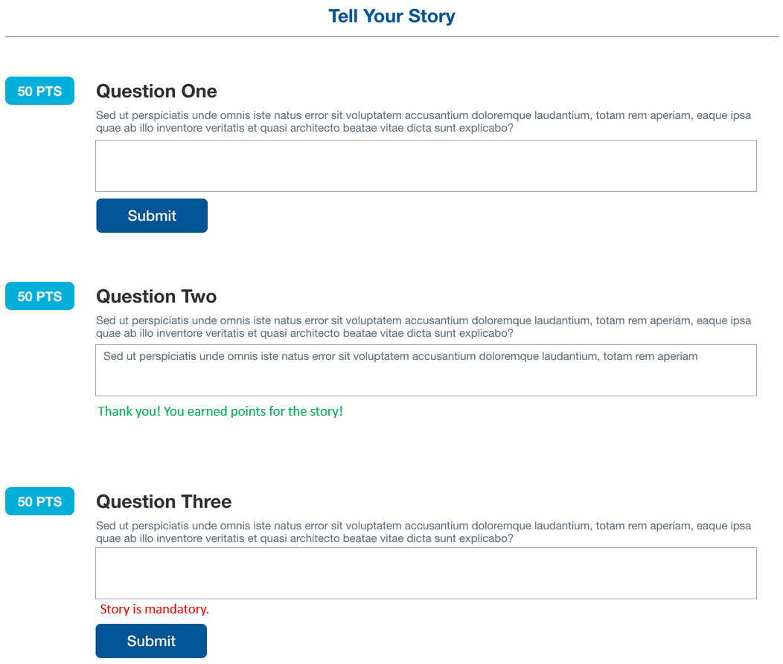

[Tech Note:

* Add into user profile ACF custom fields:
  + Story Title 1. Text. Optional;
  + Story 1. Text area. Optional;
  + Story Title 2. Text. Optional;
  + Story 2. Text area. Optional;
  + Story Title 3. Text. Optional;
  + Story 3. Text area. Optional]

[PM: setup Admincolumns for users with a custom set to see what users what stories posted + export]

Controls description:

* 3 sections with questions and description. These are pre-defined static text sections.
* 3 sections with stories.
  + Stories:
    - Story 1: [Tech Note: text for answer 1 is stored in User Profile->Story 1];
      * Text area with maximum 1000 chars.
      * If user not answered this question yet, then it is empty and editable.
      * If user already answered it, then text is pre-populated and not editable
    - Story 2 and 3. The same as ‘Story 1’, but they use **User Profile->Story 2 and 3** accordingly.
  + ‘Submit’
    - If user already answered it [Tech Note: answered means – **User Profile->Story X** is not empty], then:
      * Button is hidden;
      * The following text is displayed:

|  |  |
| --- | --- |
| **English** | Thank you! You earned points for the story! |
| **French** | Je vous remercie! Vous avez gagné des points pour l'histoire! |

* + - If user is not answered yet, then:
      * Button is visible and clicking this button does the following:
        + If story is empty [Tech Note: trim all spaces before validating], then show an error message above the button saying:

|  |  |
| --- | --- |
| **English** | Story is a mandatory. |
| **French** | L'histoire est obligatoire. |

* + - * + If story was provided, but is < 100 chars, then show an error message above the button saying:

|  |  |
| --- | --- |
| **English** | Provide at least 100 chars for your story. |
| **French** | Fournissez au moins 100 caractères pour votre histoire. |

* + - * + If all is OK, then:

Add points – see chapter ‘Points’;

Cut story to 1000chars, if it was longer;

Save the following story details:

Save Story question (static text above) in **User Profile->Story Title X** (it can be in EN or FR based on website language);

Save Story content (which user entered) in **User Profile->Story X**;

Show a thank you message as described above;

Hide ‘Submit’ button.

# Administrative Interface

## Page ‘CPA Settings’

These are settings for CPA project.

It may look like this:

|  |  |  |  |  |  |  |  |  |  |  |  |  |  |  |  |  |  |  |  |
| --- | --- | --- | --- | --- | --- | --- | --- | --- | --- | --- | --- | --- | --- | --- | --- | --- | --- | --- | --- |
| **CPA Settings**   |  |  | | --- | --- | | **Downloads** |  | | **Home page downloads**  *Make a list of downloads which should be displayed on the Home page*   |  | | --- | | <this is a repeater or just select from list control>  [Download 1] 🞩  [Download 2] 🞩  …  [Add Download] | | |  |  |  | | --- | --- | | **Winners** |  | | **Home page winners**  *Make a list of winners who should be displayed on the Home page*   |  | | --- | | <this is a repeater or just select from list control >  [Winner 1] 🞩  [Winner 2] 🞩  …  [Add Winner] | | |  |  |  | | --- | --- | | **Challenges** |  | | *This is a repeater, which may include all current and future challenges. It allows to show / hide them by changing Challenge Visibility option.*  **Challenge Tiles**   |  |  |  | | --- | --- | --- | | 1 | **Tile Location \***  *Select where a tile should be displayed. Each page may have many pre-defined and not visible tiles. They will be activated manually one by one when time occurs.*  (*) Home page ( ) Challenges page  **Show Tile**  *If checked then it is visible in Location above, otherwise it is not visible. Unselected by default. This tile can be prepared and hidden until a challenge date.*  [X]  **Image**  *This is image to be displayed in the Challenge section. Empty by default.*  [Special control to select an image]  **Content**  *This is content which may be displayed over the image. If there is no Image, then content is not displayed as well.*   |  | | --- | | [HTML editor, because content can be with styles] |   **Button Title**  *This is title on the button. Default ‘Take this Challenge’. If there is no title, then button is not displayed*  [___________________________________________]  **Open Page**  *This is a list of pages, challenges and responses to be opened when image or buttons are clicked. Empty by default.*  [Special reference control to select page, challenge of response] | | … |  |   [Add Row] | | |

Controls description:

|  |
| --- |
| **Tab** ‘**Downloads**’   * Home page downloads.   + This is a repeater to select download from custom-posts be displayed on the Home page |
| **Tab** ‘**Winners**’   * Home page winners.   + This is a repeater to select winner custom-posts be displayed on the Home page |
| **Tab ‘Challenges’**   * This is a repeater. We can prepare all challenges and add them into the list. When dates occur we can show/hide them.   + Tiles can be located on Home page or Challenges page;   + All fields are optional and described on the screen above. * Examples:   + Home page tile:      * + Image + Button:      * + Image + Text + Button |

## Page ‘Challenges’

[Tech Note: this is a custom post and AdminColumns for better managing]

NOTE: all challenges can be added in advance and then selected from CPA Settings what should be displayed on the website.

Challenges are used to link people responses for a particular challenge.

The list will look like any custom post list looks like in WP admin. No changes required.

### Page ‘Add/Modify Challenge’

This page is used to add a particular challenge on the website.

It may look like standard Add/Modify page, with some exceptions:

* Standard fields:
  + Post title.
    - This is a Challenge name on a website
  + Content.
    - This is a challenge description on a website
* Custom fields (ACF controls):
  + **Type** – this is a drop-down with two values: Daily or Weekly
    - Mandatory;
    - This type will be used to grand different badges for submitting responses into different challenge types.

## Page ‘Challenge Responses’

This is a custom post for saving users responses for particular challenges from the website.

For example:

* 10 users may post their responses on a challenge which asks to post an image or video.

List of responses may look like this:

* Standard WP columns
* Additional Columns:
  + Challenge Name
  + User Name

Apply AdminColumns to allow export responses into excel for client review.

### Page ‘Modify Response’

No need to add response, but Admin should have possibility to modify or delete it.

This page may look like this:

|  |
| --- |
| -- BEGIN Standard fields  Title  Content  -- END Standard fields  -- BEGIN Custom fields  **Challenge Name \***  [This can be a control to select challenge from the list▼]  **User Name \***  [This can be a control to select user from the list▼]  **Image**  [Image preview control]  **Video**  [Video preview control]  -- END Custom fields |

Controls description:

* Title. This is a challenge name on which user posted response.
  + NOTE: It duplicates the [Challenge Name], but I want to have it in case if we decide to generate it differently
* Content. This is text which uses posted for a particular challenge
* Challenge Name. This is a challenge name for which user responded
  + Mandatory.
* User Name. This is user name who posted a response
  + Mandatory.
* Image. This is an image which user may upload for a challenge response
  + Optional
* Video. This is an video which user may upload for a challenge response
  + Optional

## Page ‘Winners’

Winners should be a custom post type, to display them in different places.

List and Add/Modify pages will be like standard WP posts, with one custom field:

* Standard fields:
  + Post->Title – Winner name
  + Post->Content – Description. I think here client will add details in what challenge he/she won;
  + Post->Featured Image – Winner image
* Custom fields (ACF controls):
  + **User** – this is control to select user from existing list
    - Optional. In case if winner is not in the list of existing users ☺;

## Page ‘Downloads’

This is a custom post type.

List and Add/Modify pages will be like standard WP posts, with fields field:

* Standard fields:
  + Post->Title – Download title
  + Post->Content – Download description
  + Post->Featured Image – Download thumbnail: small preview image of a Post->File
  + Post->Publish Date/time – Download date/time
* Custom fields (ACF controls):
  + **File** –control to select a file for downloading.
    - Mandatory. Cannot be downloads without files

## Page ‘Events’

This is a custom post type.

List and Add/Modify pages will be like standard WP posts, with fields field:

* Standard fields:
  + Post->Title – Event title
  + Post->Content – Event description
  + Post->Featured Image – Event thumbnail
* Custom fields (ACF controls):
  + **Language** – drop-down with two options: English, French.
    - Mandatory.
  + **Event Start Date/Time** – date/time control to select date/time when event starts in EST timezone
    - Mandatory
  + **Duration** – textbox field. Example ‘*8:45AM EST – 10:30AM EST*’
    - Mandatory
  + **Registration Link** – this is control to select external URL.
    - Mandatory

# Appendix

## User Permissions

This describes user roles and permissions

|  |  |  |
| --- | --- | --- |
| **Permissions / User role** | **Public user (not logged in)** | **Logged In user** |
| See all content in read only mode | Yes | Yes |
| Comment articles | No | Yes |
| Comment in forums | No | Yes |
| Earn points | No | Yes |
| Complete User Profile | N/A | Yes |
| Add topics into forums | No | Yes |

## Points

[Jul 2, 2020 updated by Sam]

[Tech Note: automatically display how many points user gains on the screen using this plugin

https://mycred.me/store/notifications-plus-add-on/]

[Tech Note: inside the admin interface we need to know for what each points were added. Example:

* Date/time;
* User;
* Notification notes;
* Points]

|  |  |  |  |
| --- | --- | --- | --- |
| **ACTION** | **DETAILS** | **RULES / NOTES / NOTIFICATION** | **POINTS ALLOCATION** |
| Enroll step 1 | Social or traditional enrollment | **Notification:**  *‘You have received* ***<X> points*** *for* ***enrolling to site****’* | 25 |
| Enroll step 2 | Filling out full profile post enrollment | When profile shows "100% complete"  **Notification:**  *‘You have received* ***<X> points*** *for* ***filling out profile****’* | 50 |
| Login |  | points earned once per day, even if user logs in 10 times per day. Auto-login is considered as login as well.  **Notification:**  *‘You have received* ***<X> points*** *for* ***logging to site****’* | 10 |
| Weekly challenge | Posts response to challenge | For every first response in each challenge.   * If user submitted 10 responses for the same challenge, then only 50 points will be granted.   **Notification:**  *‘You have received* ***<X> points*** *for* ***posting response to challenge ‘<challenge name>’****’* | 50 |
| Daily or NPW challenge | Posts response to challenge | For every first response in each challenge.   * If user submitted 10 responses for the same challenge, then only 25 points will be granted.   **Notification:**  *‘You have received* ***<X> points*** *for* ***posting response to challenge ‘<challenge name>’****’* | 25 |
| Challenge social share | After completing weekly or daily challenges, sharing via social | Once per share per response.   * Each response has 4 shared icons. Points granted only for the first clicked share button. User may click to share on Facebook and Twitter for a response, but he/she gets only 20 points in total * User may share different responses. Sharing of each response give 20 points.   **Notification:**  *‘You have received* ***<X> points*** *for* ***sharing response ‘<challenge name>’****’* | 20 |
| Download image/pdf | When user clicks "download" | Once per item for lifetime   * Even if user clicked Download 10 times, then system grands only max 5 points.   **Notification:**  *‘You have received* ***<X> points*** *for* ***downloading ‘<download title>’****’* | 5 |
| Share image/pdf | When user shares image/pdf | Once per item for lifetime   * Even if user clicks different share icons for the same item 10 times, then system grands only max 5 points for each Download item.   **Notification:**  *‘You have received* ***<X> points*** *for* ***sharing ‘<download title>’****’* | 5 |
| Forum post | When user adds a question to forum | Once per post.   * Each post gives 10 points. If user adds 10 posts, the he/she receives 10*10=100 points   [Jul 3, 2020: confirmed by Sam] So, if user posts 100 posts per day, then he receives 100 * 10. No limitations per day  **Notification:**  *‘You have received* ***<X> points*** *for* ***adding a forum post ‘<post title>’****’* | 10 |
| Forum comment | When user replies | Once per comment.  [Jul 3, 2020: confirmed by Sam] So, if user posts 100 comments per day, then he receives 100 * 10. No limitations per day.  **Notification:**  *‘You have received* ***<X> points*** *for* ***commenting on forum****’* | 5 |
| Refer a Colleague | When user sends a referral through site, once per day | Once per day   * If yesterday user submits 3 emails, then he gets today 3*10=30 points * If today user submits 2 emails in the form, then he gets today 1*10=10 points.   **Notification:**  *‘You have received* ***<X> points*** *for* ***referring a colleagues****’* | 10 points each email |
| Testimonial/Tell Us Your Story | When use answers one of the 3 questions posted | There 3 questions on the form. Submitting one question gives 75 points. Maximum user can submits 3 questions = 3*75 = 225 points.  **Notification:**  *‘You have received* ***<X> points*** *for* ***submitting a story****’* | 75 points each story |

## Badges

[Jul 11, 2020 list of badges was approved by client]

[Tech Note: automatically display what badge user gains on the screen using this plugin

https://mycred.me/store/notifications-plus-add-on/]

Badges source files are here:

\Shared drives\Project_Docs-Specifications-Creative\CPA_PayrollWeek\Creative\CPA Badges\Renders\July_08\..

|  |  |  |
| --- | --- | --- |
| **Badge** | **Thumbnail** | **Rules** |
| Payroll Sparkplug |  | Reaches 200 points |
| Payroll Dynamo |  | Reaches 500 points |
| Payroll Powerhouse |  | Highest points on end of day, September 25th, 2020  [Dev Note: can it be automated? Otherwise we can set this manually  to simplify algorithms. Note” Badges supports manual assignments] |
| Amplifier Badge |  | When user shares any item from the site, awarded on first social share.   * When user clicks hare icon on Downloads or Responses |
| Generator Badge |  | When user posts their first question or reply in forum |
| Mentor Badge |  | When user posts/replies 10x or more in the forum |
| Pathfinder Badge |  | When user visits each page at least once  These pages include:   * Home * Challenges * Downloads * Forum * Leaderboard * About   [Dev note: we can add a repeater into User Profile and add unique visited pages into it. When user opens any page, then add this page into repeater and check if all pages above are already in this repeater, and then grand this badge] |
| Trailblazer Badge |  | Uploads responses to 3 one-day challenges [Tech Note: each challenge has a type ‘Daily’ or ‘Weekly’] |
| Information Upstart Badge |  | Downloads image or pdf from “Downloads” |
| Challenge Hot Shot |  | Uploads response to 1 weekly challenge [Tech Note: each challenge has a type ‘Daily’ or ‘Weekly’] |
| Live Wire |  | Logs in a total of 10 times |
| Rising Star |  | Enrolls on site |

Display the following in the notification area in top menu, when new badge is earned

* *‘You have earned a new badge* ***<badge name>****’*
  + Where:
    - <badge name> - see above in the table

## Sending Emails

[Open Issue: please provide emails schedule, types, creative and copy in EN and FR, before Jul 17. With Angelina: <https://app.asana.com/0/1181397601364668/1183805721266725>]

[Jul 3, 20202 from Sam] Marketing emails will be sent in two languages EN and FR. Approximate ~1,000 emails.

Newsletter copy examples:

<https://drive.google.com/open?id=1chEJly1oWz-535X-seNUbo4uJ5Pe1142&authuser=angelina%40senseimarketing.com&usp=drive_fs>

Banner images to use: <https://drive.google.com/open?id=1akfuNISeyUrAm3lcBA1X6k4hJHEU0vCj&authuser=angelina%40senseimarketing.com&usp=drive_fs>